Local Cave & Mine Leader Award

Caving Belts

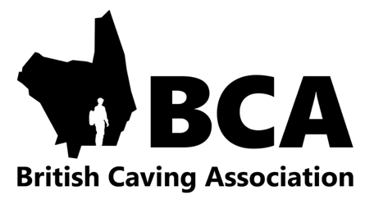

**Disclaimer**

Neither the authors nor British Caving Association assume any responsibility for the improper application of the techniques or principles outlined in this document. Use of these techniques are at the user’s risk. The techniques illustrated in this document provide supporting information for the Local Cave & Mine Leader Award syllabus and should be read with the remit of that award in mind. This document is not a substitute for attending certified training courses.

This document is openly available on the condition that it is not distributed for commercial gain, other than in support of any British Caving Association Award Scheme. You are welcome to share and use all or parts of this document, however please acknowledge the authors.



**Introduction**

This document has been produced on behalf of the Qualification Management Committee (QMC) of the British Caving Association. Its purpose is to support candidates preparing for the Local Cave and Mine Leader Award.

Author: Richard Hill based on testing by the Derbyshire & North Wales T/A panels together with support from Trainer/Assessors of the LCMLA scheme. Photos by

Published XXXX

**Contents**

|  |  |
| --- | --- |
| * Caving Belts in Cave/Mine Leader Award Situations * Belts & PPE * Which Belt? * Considerations in use * Care and Maintenance * Appendix 1: ‘Heavy Duty ‘ Caving belt testing LCMLA Trainer/assessor workshop 12/12/15 | * Appendix 3: Further tests on Caving Belts April 2018 * Appendix 2: Belts tested at a North Wales BCA workshop. April 2014 Appendix 3: Further tests on Caving Belts April 2018 * Appendix 4: Testing the strength of heavy duty caving belts |

**Caving Belts in Cave/Mine Leader Award Situations**

Historically the Caving Belt was used to be either load-bearing or non load-bearing depending on the type of use it would receive. Often a simple non load bearing belt (25mm width) was worn for carrying a lamp battery. However, it was recognised that a belt could also be used as means of assisting people whilst spotting climbs and other awkward manoeuvres or as a method for attaching cowstails and ropes on short climbs, slopes and traverses.

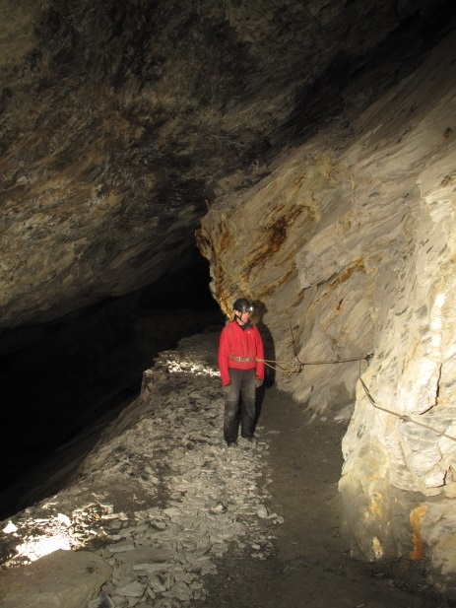

Photo 1: Belt used to prevent reaching to a hazard

In these situations, a belt capable of handling a load with relative comfort (45-50mm width) with a locking buckle system was required and manufacturers provided, what at the time was known as, the ‘Load Bearing Belt’.

The BCA Award scheme allows leaders to take groups into situations where a fall may be serious.

At Cave Leader or Mine Leader Award level the ground that the group is moving over should be simple enough that progress on steep or challenging ground can be safeguarded largely through spotting techniques. There may be times when groups may near steep drops where a fixed handline rope could be secured to a belt to prevent a group member reaching the steep ground and falling (see photo 1).

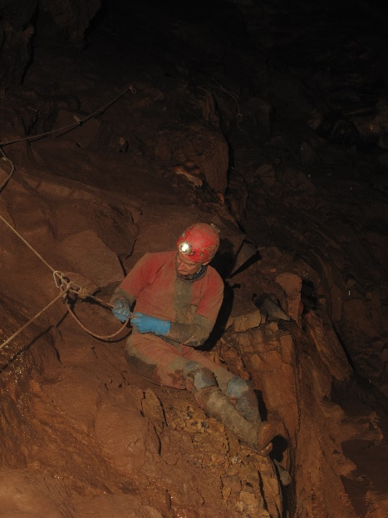

Photos 2: Belt is use; preventing a fall

Alternatively, there may be steps which are relatively straight forward, however the leader may not be able to safely position themselves at an awkward step to spot effectively, and so a belt together with a rope may be used to prevent a slip from turning into a fall (see photo 2).

Critically within the remit of the Cave/Mine Leader a group member should never be suspended from a caving belt.

For more details see the BCA Cave/Mine leader ropework document: <https://british-caving.org.uk/documents/ropeworks-for-cave-mine-leaders/>

At Vertical cave or mine Leader award level a slip may mean that the group member is suspended (see photo 3). If this is a possibility, then the group member must wear an appropriate harness NOT a belt.

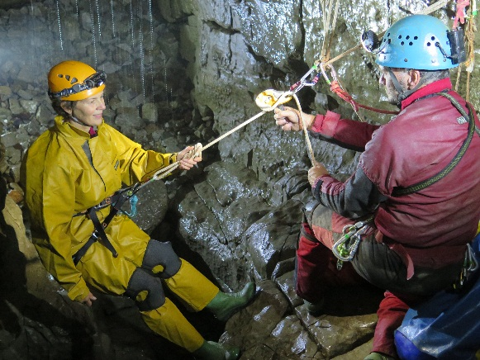

Photo 3: Belts must NOT be used in this situation

For more details see the BCA Vertical Cave/Mine Leader ropework document: <https://british-caving.org.uk/documents/vertical-leader-ropework/>

**Belts & PPE**

With the introdction of PPE legistlation standards were drawn up, predminantly with the rope access industry in mind. Within industry there is a standard (EN358) for Belts (and lanyadrs) for work positioning or restraint.

At face value this standard would appear approrite to adopt for choosing a caving belt, however in practice these need to meet a range of criteria (such as requiring a back support, load bearing attachment points and a complex buckle arrangment) which make them impractical for caving.

There is no standard for a Caving Belt and those available to purchase are not defined as PPE.

**Which Belt?**

As there is no standard for a Caving Belt leaders will need to make careful choice when selecting a belt approriate for use within the remit of the award scheme. These considerations may incude;

* Width of belt (to ensure they are reasonably comfortable in use)
* Sutable adjustable buckle (which is sutably robust for its intended use, and cannot come undone through normal caving/mine exporation activities)
* Sourced from a reputable outdoor/caving dealer (preferably one that has been manufactured for use as a Caving Belt)

How strong a Caving Belt needs to be is a challenging question. Work Positioning belts are tested to 15kN, the same requirement for a climbing harness. Given the intended use of a Caving Belt this would seem excessive.

In practice a Caving Belt should never be used to support more than an individuals weight, and never in a dynamic situation (drop tests conducted during a LCMLA Trainer/Assessor workshop illustrates this, see appendix 1). However, some consideration should be made with regards wear to a belt, particularly in a caving environment. The selction of a sutably robust belt manufactured from compoents simular to those used in a climbing/caving harness would be approriate.

Trainer/Assessors within the LCMLA scheme pull tested a range of Caving Belts (see appendix 2, 3 & 4) beyond the loads they should every experienced providing confidence in many of the Caving Belts currently available and in use.

Further work (see appendix 4) suggests a simple testing regime leaders could conduct themsleves to supprt the choice of Caving Belt should leaders feel this is necessary.

**Considerations in use**

When in use leaders should take care as to where a buckle is positioned so that the webbing of the belt is not subjected to excessive wear, or cause discomfort to the group member. Buckles should be checked periodically, especially before use within some of the rope work techniques taught within the remit of the Local Cave and Mine Leader scheme, as they may work loose through the rigours of a cave or mine exploration activity.

Leaders should also take are when attaching a karabiner or cowstails to a belt to ensure they are positioned in such a way so as not to affect the buckle and secured to an appropriate part of the belt (see photo 4).

Photo 4: Karabiner clipped to the webbing, buckle to the sire

**Care and Maintenance**

Although Caving belts are not PPE they should be inspected in a similar way to other technical equipment to ensure that they remain fit for purpose. The belt should not be significantly frayed or damaged.

Because the belts are not PPE manufacturers do not suggest a lifespan, however, as leaders, we need to ensure that they are fit for purpose.

As can be seen in the appendices below some belts pass tests when well over 10 years old but others have deformed (although not failed catastrophically) when new, so a suggested life of 15 years would seem sensible. Of course, any piece of equipment may need retiring after it’s first use if for some reason it has been subject to an extreme load/force.

Below are some examples of Caving Belts that may still be fir for purpose, or may be reaching the end of their lifespan.

|  |  |
| --- | --- |
|  | A relatively new belt with only minor scuffs |
|  | Fraying beyond repair |
|  | Age questionable, however no significant fraying, may be suitable for use |
|  | Minor fraying, belt would need monitoring but may be suitable for continued use. |

**Appendix 1:** ‘**Heavy Duty ‘ Caving belt testing LCMLA Trainer/assessor workshop 12/12/15**

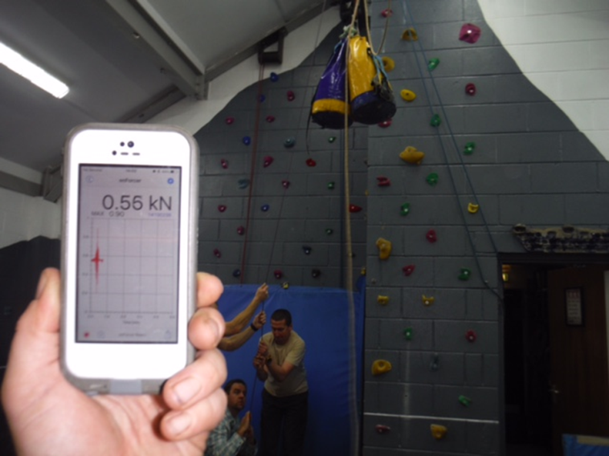

Photo 1

A range of belts were tested during a LCMLA trainer/assessor workshop (12/12/15) held at Hagg Farm Outdoor Education Centre Derbyshire.

The belts were subjected to a drop test of an approximate fall factor 0.5 (with a drop of about 1.75m) with a mass of 55kg (photos 1 and 2). A load cell was included in the rig which gave an impact force of around 4.4kN (diagram 1)

Photo 2

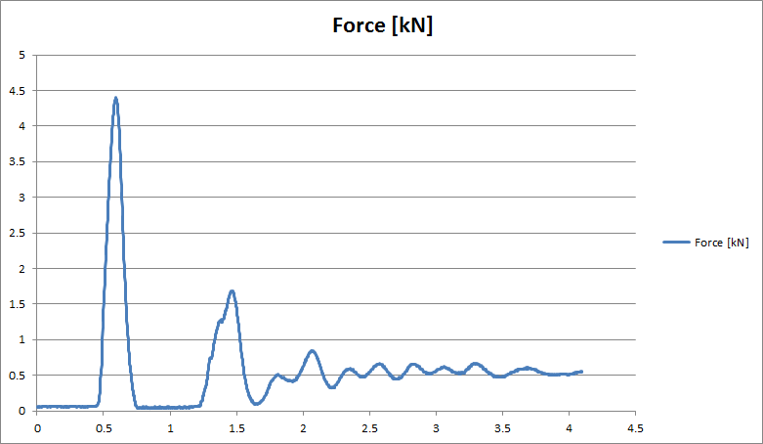

Diagram 1

Insulation tape was placed up against the buckle to measure any slippage and the belts inspected afterwards for damage. The belts were subjected to one drop only. The loads were considered to be far in excess of those experienced in any normal use by LCMLA/CIC holders in a working capacity.

**Test results**

|  |  |  |  |
| --- | --- | --- | --- |
| **Belt** | **Age** | **Slippage** | **Visible damage?** |
| Dragon | used | 4mm | none |
| Warmbac | new | 10mm | none |
| Troll | very old | none | none |
| Caving Supplies (yellow) | very old | none | none |
| Caving Supplies | new | 10mm | some deformity and glazing in buckle area (photo 3) |

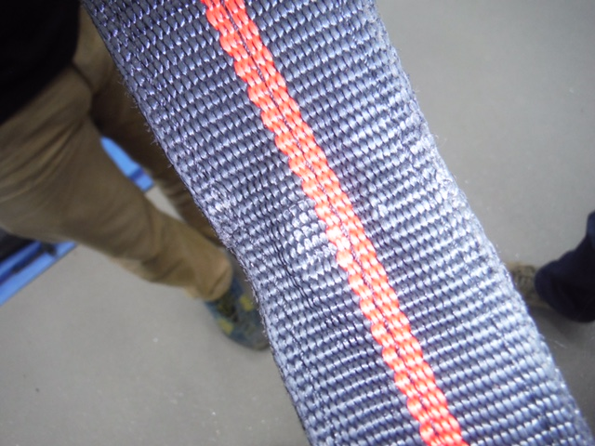

Photo 3

**Appendix 2: Belts tested at a North Wales BCA workshop. April 2014**

**www.train4underground.co.uk**

**Appendix 3: Further tests on Caving Belts April 2018**

**www.train4underground.co.uk**

**Appendix 4: Testing the strength of heavy duty caving belts**

**www.peakinstruction.com**

Posted by Pete Knight. [5th September 2017](https://www.peakinstruction.com/blog/heavy-duty-caving-belts/)

](https://www.peakinstruction.com/blog/)

**A Method of Testing the Strength of Heavy Duty Caving Belts**

The aim of this was to establish a method to test the strength of heavy duty caving belts that did not rely on having access to a load cell. I hoped to produce a simple system that needed very little equipment and that would deliver a test load to a belt that exceeded the minimum strength requirement for its use.

**What strength does a belt need to be?**

Well, this one is a potential can of worms…. Let’s be clear, the manufacturers do not condone the use of their heavy duty belts for taking any load at all beyond hanging your battery or lunch box from it. There is a historical use in cave and mine exploration that involves using the belt for the purpose of slip prevention and security on steep ground when combined with a rope belay or cowstails. If you were intending to use it for this purpose, especially as a leader of others, you’d need to be 100% sure that the belt was strong enough for that role. The manufacturers do not state this type of use is approved or list any strength rating on the product or the literature accompanying it. You must conduct your own test and risk assessment if you are to use them in this way.

*If you want an item that has a standard for this type of use, use a climbing harness, caving harness or EN358 work positioning/restraint belt.*

For anticipating loads that could be applied to a belt in use, I have used a mass that is comparable to the maximum user weight ratings on some of the common PPE equipment at the time of writing: 120kg (Mass)

The caver has a short dynamic rope lanyard of 50cm length, fixed from their belt to an anchor.

If they climb above the anchor, until the lanyard is tight, then ignoring all stretch or slack in a system, a possible FF2 fall of 1 metre can occur (Height FF2).

This FF2 fall will likely result in injury and, as a rule, cavers avoid putting themselves in a position where this kind of drop can be taken. By not climbing above the attachment point of their lanyard, the resulting fall cannot exceed FF1, or 50cm in this case. (Height FF1).

When using dynamic rope cowstails, the UIAA standard permits stretch up to 40% of original length. For a 50cm cowstail, this is 20cm, or 0.2m (Impact Distance).

**For a fall factor 2 (1m drop on to 0.5m cowstails)**

velocity = √ (distance x acceleration due to gravity x 2)

v = √ (1 x 9.81 x 2)  
v = 4.43 m/s

Kinetic energy = 0.5(mass x velocity²)

Ke =  0.5 (120 x 4.43²)     
Ke = 1177.5 Joules

Impact force = Kinetic energy / Impact distance

IF = 1177.5 / 0.2  
IF = 5887.5 N

**Impact Force = 5.89 kN**

This is clearly a very serious amount of force and is only a hair under the threshold that the work at height industry uses as a maximum safe force the human body should be subjected to. An impact of around 6kN on the body will cause injury in a lot of cases and should certainly never be taken on a heavy duty caving belt. It is beyond anything we should ever do when wearing belts and is included only to demonstrate the risk of improper use. A FF1 drop is still something to be avoided, but is more realistic of a potential real world scenario.

**For a fall factor 1 (0.5m drop on to 0.5m cowstails)**

velocity = √ (distance x acceleration due to gravity x 2)

v = √ (0.5 x 9.81 x 2)  
v =  3.13 m/s

Kinetic energy = 0.5(mass x velocity²)

Ke =  0.5 (120 x 3.13²)     
Ke =  587.8 Joules

Impact force = Kinetic energy / Impact distance

IF = 587.8 / 0.2  
IF = 2939 N

**Impact Force = 2.94 kN**

So a 0.5m drop on to a 0.5m dynamic lanyard may produce a force of around 3kN for a 120kg caver. This does not take into account any stretch or bounce. This figure seems pretty reasonable, but we should seek more evidence to reinforce this for our follow up testing.

When considering the use of caving belts, can we can compare it to something done in another industry? Well yes, work restraint systems often make use of padded restraint belts instead of harnesses. One of the critical requirements for this system is that a user may not be permitted to go into suspension on this system. That seems very close to how we should be using heavy duty caving belts. When consulting BS8437 – *Code of practice for the selection use and maintenance of personal fall protections systems and equipment for use in the workplace*, we can identify that restraint belts need to conform to EN 358. Accessing this standard is expensive and no doubt the items conforming to this standard will have a very high safety factor. What we can get from BS8437 is the recommended strength of anchor points for use in a work restraint system. **This is 3 x the mass of the user.** A correctly installed and utilised work restraint system is only required to have an anchor of 3 x user’s mass. For our 120kg caver, this would be 360kg, or 3.6kN in force.

For our 120kg fictitious caver, we can mathematically predict a theoretical force of just under 3kN for a FF1 drop. We can also see that and anchor of 360kg (3.6kN) would be required if using similar techniques in work restraint. The figures are not exactly a match, but are comparable. **Taking the worse case figure is probably the safest option going forward, so our belts must be capable of taking a force greater than 3.6kN for a scenario that does not involve wildly inappropriate use.**

**Safety Factor?**

Apply to this any safety factor you wish. The 3kN figure from the maths is indicative of the maximum possible force generated in a FF1 drop on 50cm cowstails, the real world figure will be far lower due to stretch and slippage of the belt on the body and the sagging of the rope the caver is connected to. The BS8437 figure is a 3 x safety factor over the user’s mass anyway. You could easily argue that belts tested to 3.6kN would be sufficient as an indicator of appropriate strength if you never operated with cavers heavier than 120kg.

**Belt Strength**

Accepting all this, we are left with the figure of 3.6kN as a minimum requirement for the strength of the heavy duty caving belt for any user we might encounter regularly (3 x 120kg based on BS8437).

So as long as we can apply a test force of 3.6kN or more to the belt, we can be assured that the item can hold the greatest possible force we can apply to it in proper use. The only remaining factor of concern is that would applying this force in test render the belt unsafe to use again, in essence, are these tests destructive? Only 1 way find out…..

**Testing**

Using 1 very large Corsican Pine and a good sized Birch tree, we set up a pull testing rig with a simple 3:1 theoretical configuration. I used a Rock Exotica load cell to get live feedback on the testing here but if you copy the method, you would not need to use one.

For the estimation of test force we regarded each person capable of pulling 50kg (see [Gethin Thomas’](http://www.train4underground.co.uk/tyrolean/) work on tyroleans). Through a theoretical 3:1 MA system that would be 150kg per person. With 5 undertaking the pull reaching 750kg and 6 equaling 900kg or approximately 7.5kn and 9kN respectively.

Kit used (minus load cell): Petzl rescue pulley, Petzl Basic jammer, Petzl Partner pulley, Lyon wire sling for tree, assorted karabiners, 20m rope.

Due to the force expected to be placed on the rope, I did not anticipate that I would be able to untie the end knot (fig 8 loop). This was accurate and the knot had to be cut from the rope end. Bare this in mind with your own rope!

We also used a Petzl Rollclip to redirect the angle of pull to make it easier to stand on the tarmac of the road alongside the trees.

Initially we had 5 people pulling the first test on a Lyon roller-buckle belt (brand new).  
This produced a force of 5.9kN with no damage or slippage. This is lower than expected but there was a lot of tightening in the knot and stretch in the rope coupled with a general timidness of the pulling team.

|  |  |
| --- | --- |
|  |  |
|  |  |

The remaining tests used 6 people to pull. This one was conducted on my 10 year old Caving Supplies square buckle belt (already retired). This belt has nicks, fluff and rust and comfortably took a force of 7.74kN showing no damage or slippage. Next came my current AV belt, with it’s central maillon removed and directly attached to the pull line. This belt held 7.7kN without failure or slippage. Finally, the pulling team seemed at their most confident that nothing was going to break and send shards of metal and wood at them so they really gave the last belt some pain. This Warmbac square buckle belt was subjected to 8.64kN with no damage or slippage noted at the time.

It is not surprising that the force exerted by the pulling team was less than the theoretical 3:1 system implied. In practice with the loss of friction due to bearings and turns in the rope a 2.5:1 is a more real world figure and so our 5 x 50kg pulling average adults could be expected to make 625kg/6.25kN using this system.

On this test we pulled the belts to a far higher force than would be needed in a periodical strength test to simply demonstrate that this lower level of testing would not damage the belts. Using 4 people to pull on a 3:1 MA (2.5:1 actual) system in a reasonable way with un-gloved hands, would produce a force exceeding 3.6kN. This would not require a load cell to demonstrate if the method was followed correctly. Using 3 strong people on the same 3:1 (2.5 actual) system would probably be reasonable too.

50kg x 4 people = 200kg x 2.5 mechanical advantage = 500kg or 5kN  
50kg x 3 people = 150kg x 2.5 mechanical advantage = 375kg or 3.75kN

**Conclusions**

Using a system like the one shown here, with 4 people pulling at average strengths, you can apply a force greater than 3.6kN to your test belt.

Once the test is complete you should thoroughly examine the belt like any other item of textile PPE to see if any damage or slippage has occurred. Any that do show signs of damage should be retired. Any slippage may be down to the buckle, but if the belt comes off or strap slides through the buckle under load, it should be deemed as having failed. If a belt has taken the test load and shows no damage or deformity then you can be comfortably sure that the belt will be fit for its intended use whilst still in that condition.

**Final inspection of belts:**

|  |  |  |
| --- | --- | --- |
| **Belt** | **Max load** | **Observations** |
| Lyon roller buckle | 5.9kN | No damage |
| Caving Supplies square buckle | 7.74kN | No damage |
| AV maillon closed harness buckle | 7.7kN | No damage |
| Warmbac square buckle | 8.64kN | No damage, slight curvature to webbing now when hung vertically which indicates over stretching or broken fibers down one side. |

Again, this level of force was beyond what you would test to, but demonstrates that the 4 person 3:1 pull will not damage a belt that is not already fit for the bin.