Cave Instructor Certificate Resources:
Pull Through Caving Techniques

Disclaimer

Neither the authors nor British Caving Association assume any responsibility for the improper application of the techniques or principles outlined in this document. Use of these techniques are at the user’s risk. The techniques illustrated in this document provide supporting information for the Cave Instructor Certificate syllabus and should be read with the remit of that award in mind. This document is not a substitute for attending certified training courses.

This document is openly available on the condition that it is not distributed for commercial gain, other than in support of any British Caving Association Award Scheme. You are welcome to share and use all or parts of this document, however please acknowledge the authors.

Introduction
Pull through trips when well managed provide an exciting and swift traverse of a cave or mine system, without the encumbrance of many bags, and without the effort of uphill rope travel! It isn’t known as ‘old man’s’ caving for nothing… However some of the larger cave system traverses provide arduous journeys with many obstacles to overcome. These would be far less enjoyable and achievable if every pitch had to be rigged. Even as pull throughs they should not be underestimated.
It is difficult to find much guidance on pull through techniques, and even less so for those leading groups. This resource is to provide some information for CIC candidates but may be useful in supplementing the knowledge of cavers in general.

Pull Through Equipment
Ropes
Standard Type A caving ropes should ideally be used. Bear in mind there may well be rub points as pull through pitches commonly follow SRT routes that may normally be rebelayed. It may be worth considering thicker ropes to protect against the extra abrasion this causes.
The rope needs to be easily the length of the longest pitch doubled (unless a pull through cord is in use – best applied in lightweight/expedition situations), plus enough for the knot at the top.
Pull through trips are committing, especially with led groups. It is imperative to carry a spare rope the same length as the main rope in case it gets trapped on a pull down, or damaged during the trip.

Abseiling devices and other group equipment
It would be normal for group members to use standard SRT descending devices (Stop or similar) but given that they are not ascending, SRT kit is not always necessary. Some trips do include up pitches, in which case pre placed ladders or ropes will be needed and groups equipped accordingly. Leaders should always have SRT kit. Groups in climbing harnesses with cowstails and figure of 8 descenders are common for instructed groups. Bear in mind though , these climbing descenders work better on double ropes and are hard to control on single ropes – another reason to consider thicker ropes. They also have no autobloc mechanism. The spare rope should generally be deployed as a safety rope if a figure of 8 device being used.

Rope bags
Rope bags that drain are best in wet caves, and the rope carried are twice the normal length for the biggest pitch on the trip. So slimmer easily carried bags with handles are preferable. Obviously the spare rope should be bagged separately from the main rope.

Packing of ropes
If retrievable traverses are likely to be used, the bottom of the main rope needs to be accessible, so should be tied off at the top of the bag. Equally the top of the rope needs to be easily seen, so this too should be tied off, with a different knot to distinguish between the two ends. In the picture below the bottom end of the rope is tied off with a bowline… (note the barrel knot at the end of the rope), and the top with a figure of 8.
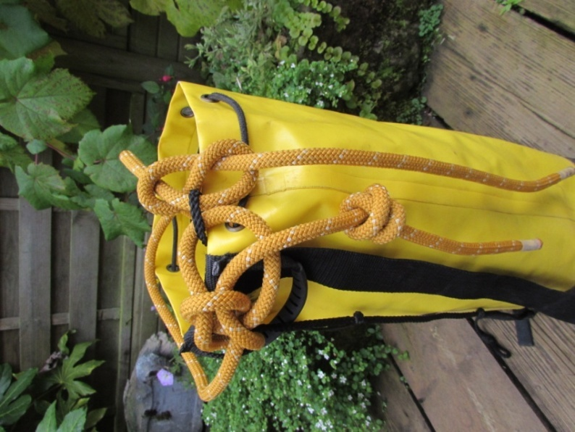

Rope Management

Anchors
Normally the abseil anchors at the pitch head would be two bolts or a combination of a bolt and a natural, tied off to equalize them to one point which is threadable. One bombproof natural may also be used. On SRT routes there may be two P (resin) bolts or plate hangers with maillons to thread (plate hangers should not be threaded). Consider the angles these are placed at – they may not be angled for pull throughs and be prepared to equalise then with supplementary equipment which will be left behind.
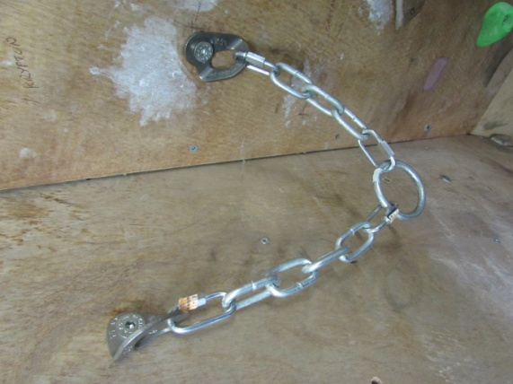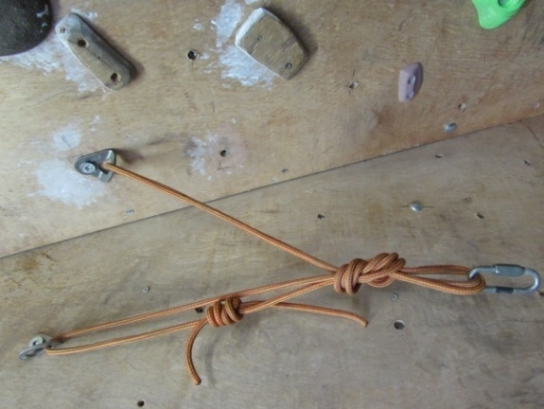
1 – ring and chains 2- rope and maillon
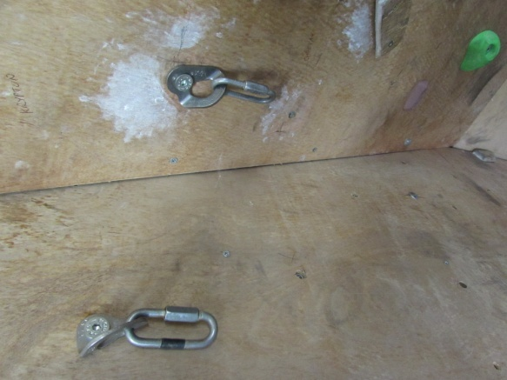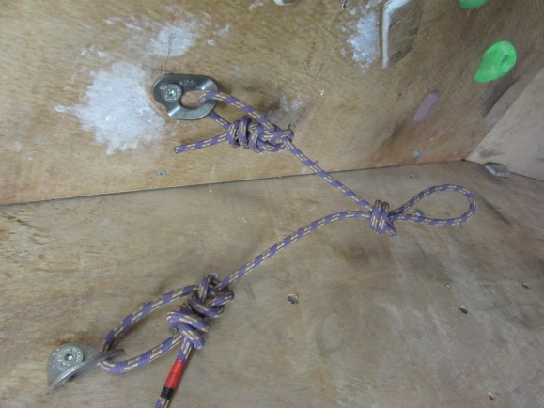
3 – plate hangers and maillons 4- old tat with no metalwork
Rings and chains set up especially for pull throughs are ideal, although a large ring can load the back bar of the connector on the rope, or allow the knot to flip through. This can be alleviated by clipping the connector through the knot as shown in Section 3.2 (photo 2) below
Pre-tied ropes should be checked for age and wear, particularly when there is no metal work on the rope (photo 4 above) as this will create a heat point and burn the sheaf as the rope is pulled through. These ropes should be replaced and a metal connector left behind.
Non connected bolts (either resin bolts or plate hangers with connectors (photo 3) may be threaded. Depending on the orientation of the bolts this may well twist the rope badly. It is preferable to equally load both anchors using chain or rope/tape.
3.2 Securing the rope
Various methods of tying off the abseil rope can be used as below:
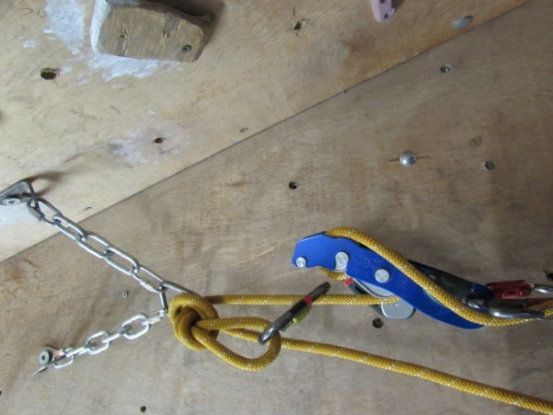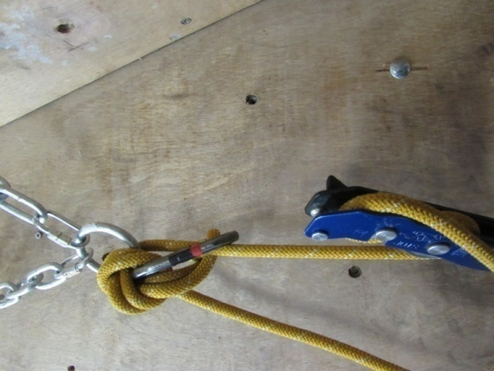
1-Overhand knot and krab 2-Overhand knot and krab
through the knot (with oversize ring)
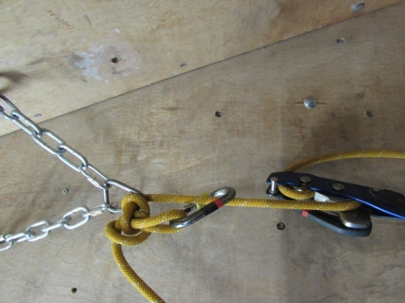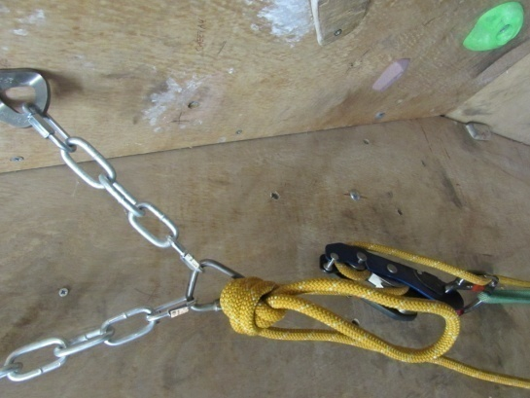
3-Alpine butterfly and krab 4-Barrel or capuchin knot butted up against a small ring or resin anchor
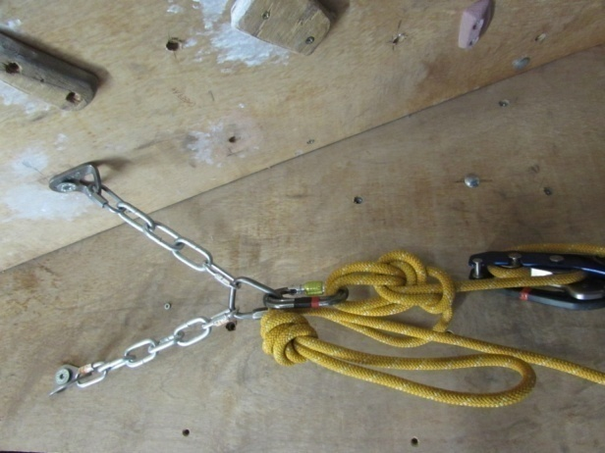
5-Bowline on the bight to tie off rope until last person descends
(the bowline unties easily after successive loads)
In all cases the abseil side should be easily accessible as the clients approach, not behind the anchor attachment.

Protecting a traverse to a pitch head
- Use of sling or short rigging rope
Pros’s – quick on short approaches, spare rope completely free for rescues
Con’s – not appropriate for longer traverses to pitch head
- Hard rig and retrieve by derigging after last group member descends
Note: in the rigging diagram below, the leader must stay in place to ensure that the groups members do not clip the last section of the traverse as it is not secured due to the pull through set up.
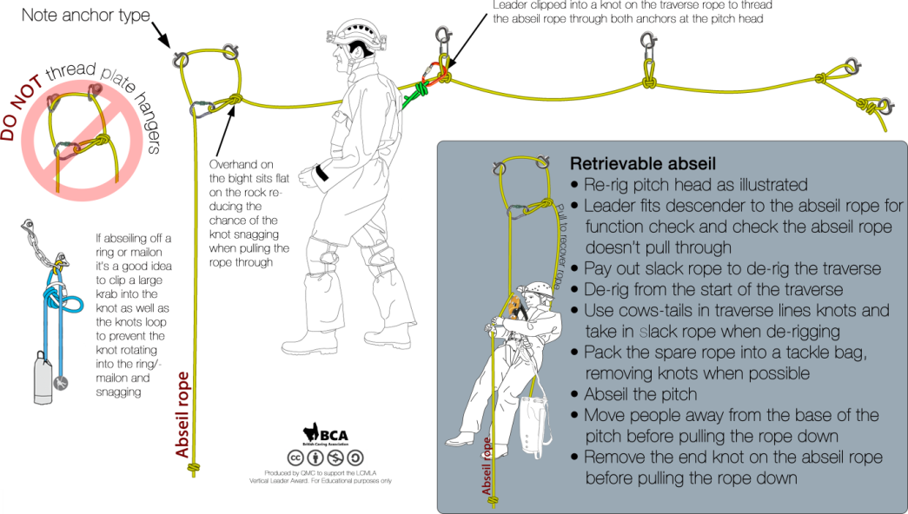
Pro’s – safe, standard technique, familiar to client (one rope, normal rigging), works on more complex traverses
Con’s –potentially slower (due to the derigging required) than a retrievable line, so delay group at base of pitch

Retrievable line using non active end of pull through rope
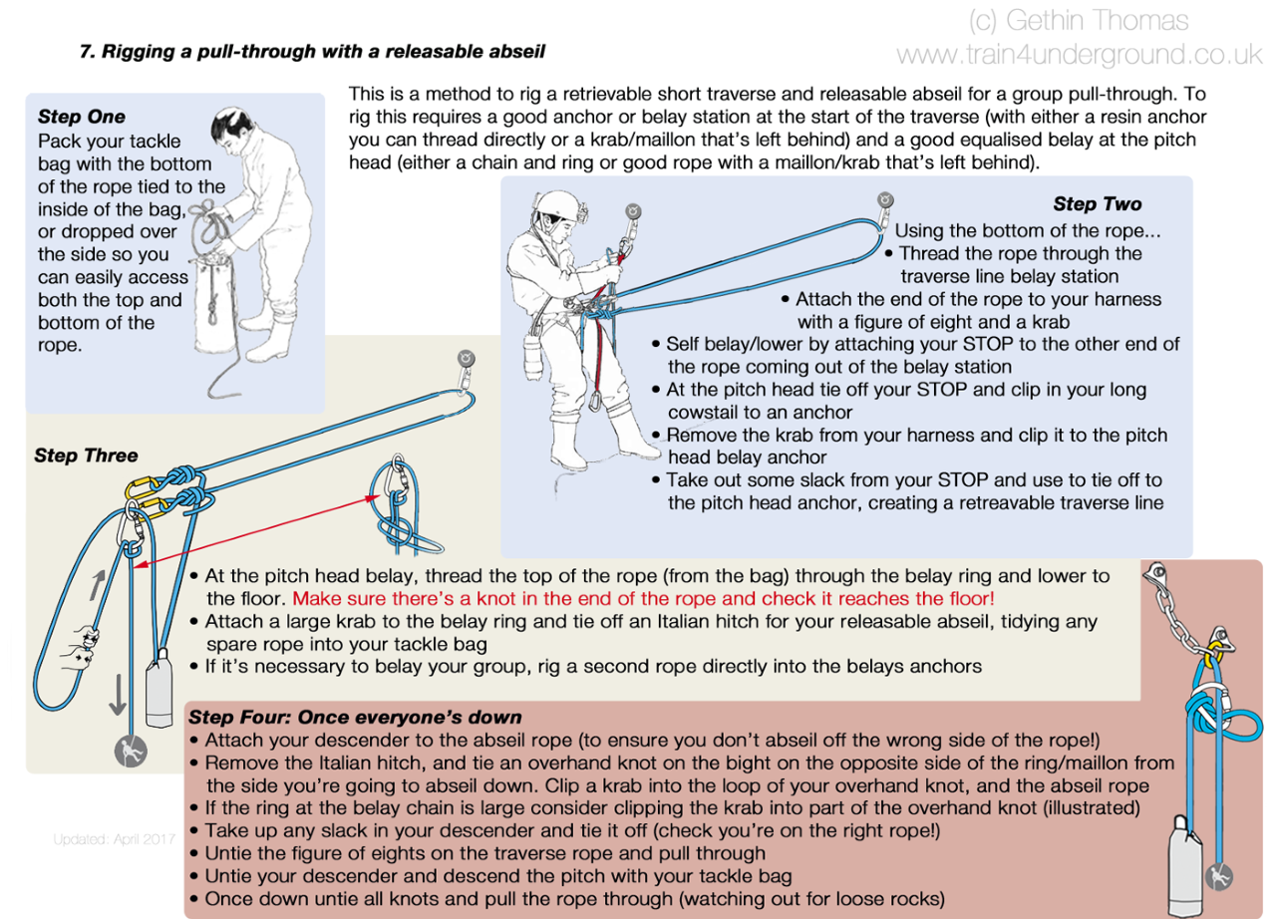

Sequence rigging a retrievable traverse with intermediate anchors

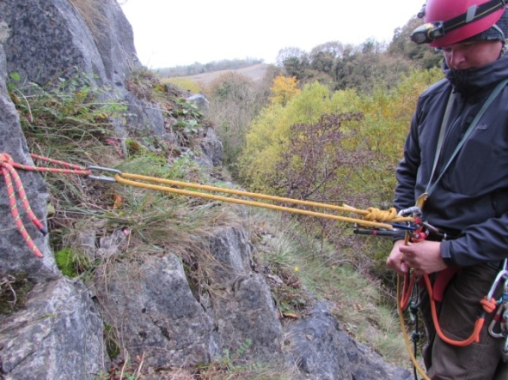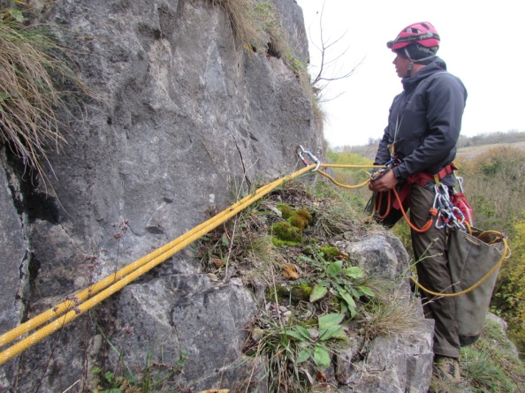
- Initial bombproof anchor 2- both ropes through connector
as leader moves along traverse
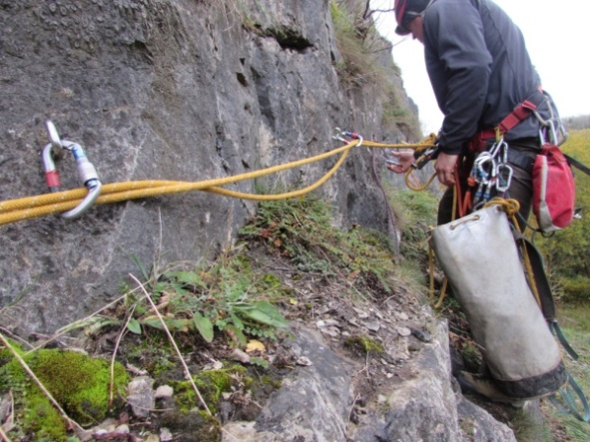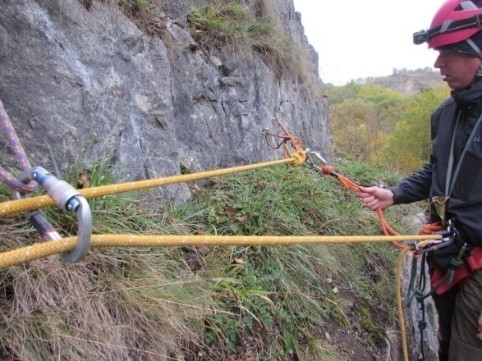
3-Repeat at each intermediate anchor 4- bottom of rope transferred to master point once leader has clipped in with cowstails, and then take slack from descender to tie off the traverse line
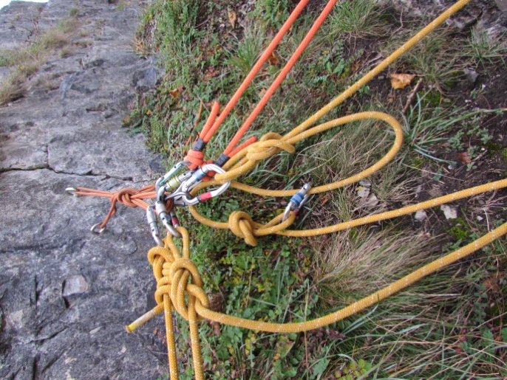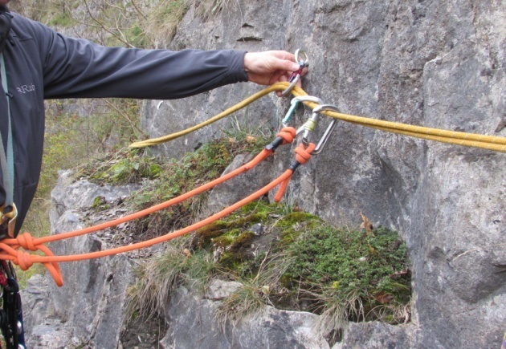
5- thread live end through master point 6- trusted last caver removes
and secure the rope (section 3.2) intermediate connectors
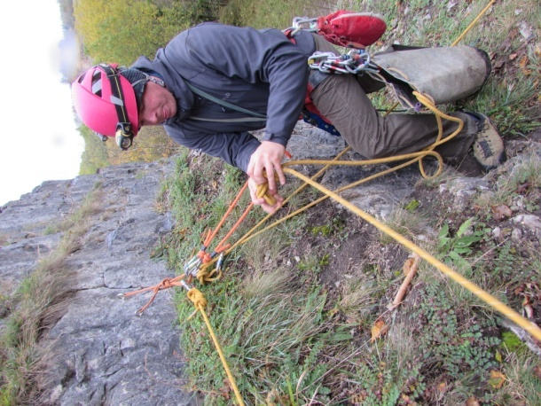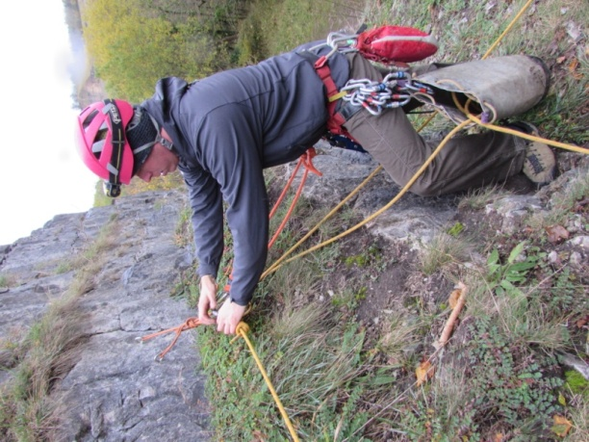
7- after last caver descends 8- release end of rope
untie traverse line and put in bag
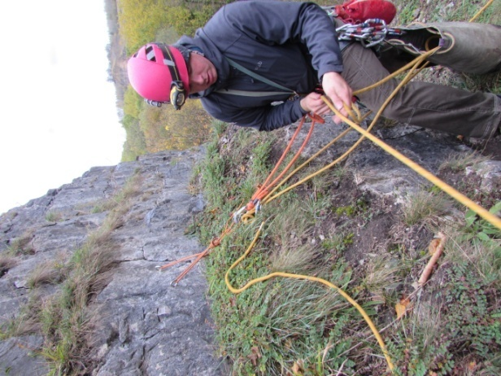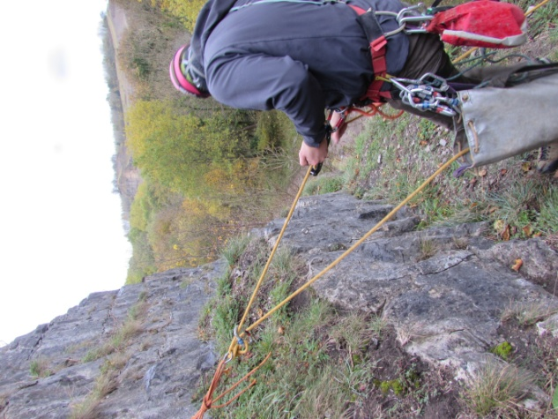
9- pull through traverse line 10 – leader descends
and put in bag
Pro’s – quick (if practiced), works on longer traverses if straight line
Con’s – potential for tangles, last client needs to retrieve karabiners from intermediate bolts so has to be trusted/some risk, needs practice to be slick

Retrieval of rope cleanly
It is not only frustrating but also adds to the commitment if the rope jams after the last caver descends! To help with a clean pull, make sure the rope pulls before the last caver goes down (brief to the penultimate caver). Ensure that there are no knots in the end, and that you are pulling the right rope! Look for twists in the rope before pulling and stand in a position which gives the cleanest pull on the rope.

Group Management

Effective communication
As with all pitches, good communication is essential with all cavers clear on the actions they need to take at the base of the pitch prior to their descent. The usual ‘rope free’ is obviously preferred but a noisy wet or long pitch may require alternative communication systems such as use of a whistle, light signals or defined tugs on the rope.

Position of leader
The leader is usually best placed at the top of the pitch to check the group members have attached to the correct side of the rope, sort the rope after the last group member has descended etc. In this position they are also able to effectively intervene if a caver has an issue on descent, using the top end of the spare rope.
However if the base of the pitch is dangerous or the pull through is a split pitch, they may need to consider being at the bottom (or part way down the pitch at the next pull through on a split pitch). This is a risky strategy, and is only likely to be applicable with groups of cavers that are experienced and with a good assistant. Robust risk assessment prior to the trip is advisable.

Best use of assistant
As with any trip, an assistant is useful and should be deployed in the most effective way – for traverses that need derigging they may be at the back, but for simple traverses maybe the bottom of the pitch to direct group members may be more appropriate. Either way clear briefings are essential.

Wet pitch management
Unlike well rigged SRT pitches, pull throughs may well enter the fall line of water. Hence effective and efficient rope management is essential, to prevent the group waiting too long when cold. The first person down could for example carry a group shelter if the base of the pitch is wet/draughting.
Before descent the group should be directed to do their suits up, and put hoods up under their helmets to prevent water ingress. Bags should be clipped to harnesses directly to stop them tangling in the rope or on projections, which could slow or even stop a smooth and swift descent.
The first person down (preferably an assistant) could take the other end of the main rope down in a tackle bag. Once the abseiler is installed on the rope this loose end can then be tensioned out of the water (by a human belay if nothing else exists) to create a guideline. Subsequent cavers can clip their cowstail into this to direct them to a drier descent. Care must be taken to ensure that once the abseiler gets off the rope it isn’t pulled down by the belay team.
This system will not work with a retrievable traverse line as the other end of the main rope is involved in the rigging (see section 3.2), in which case the spare rope could be used.

Preventing and solving likely problems

Knowing the group
By their nature pull throughs are committing and it is essential to know the group have the ability and stamina to complete the traverse the cave before embarking on the journey. If in doubt, hard rig it and go back later for the ropes!

C.L.A.P. (Communication; Line of sight; Avoidance of problem; Position of best effect)
As above in 4.1 and 4.2 this principle applies equally if not more so in pull through caving.

Retrieval of clean rope
The last caver (who may not be the leader i.e. split pitches or complex descent) selects and adjusts abseil rope. They should clip the retrieval rope with a cowstail before descending (to prevent twisting ropes), and descend a clean line. Always check that the rope pulls before last person descends.

Pitch head security, effective traverse lines and techniques
These are covered in section 3 above.

Position of leader to solve problem
As discussed above, this is nearly always at the pitch head, except split pitches

Cold wet cavers
Good wet pitch management and briefs , with appropriate equipment available at the base of the pitch to re-warm. Use a guideline as appropriate (see section 4.4). Use appropriate traverse rigging in relation to severity or consequence of slip whilst rigging/derigging. Speed and efficiency will mitigate against cold cavers, but not at the expense of safety.

Carry a spare emergency rope!

- and illuminate the area you 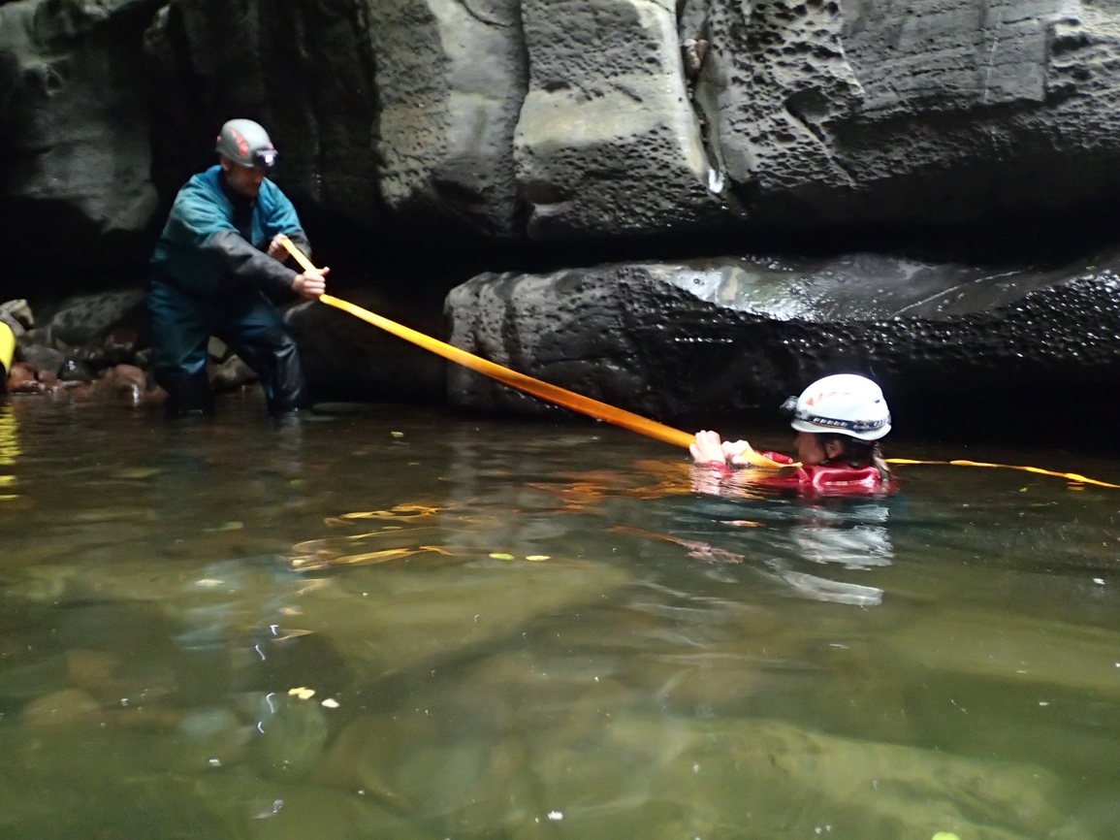want the person to move to. Avoid dazzling a swimmer.
Tape or Rope (ideally floating) used to aid a rescue
- Attempts at in-water rescue in ordinary caving clothing are at a high risk to both the casualty and rescuer. Controlled testing of in-water rescue in caving clothing has shown that buoyancy is minimal, it is hard to stay afloat, and the possibility of an effective in-water rescue is minimal.

Unconscious Casualty in the Water
An in-water contact tow is both essential and extremely urgent. Get into the water gradually and, if possible, remain connected to others on land via rope, a bag, reaching, belts, etc, whilst ensuring that whatever is used is always immediately releasable to avoid entrapment.

